Put the numbers 1-5 in the cubes of sugar.

Help the girl find the sugar.
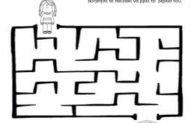
SUGAR

Paint foods that contain sugar. 